 | This is a confidential questionnaire that will help us to determine the optimal
New Patient Intake | treatment plan specific to your needs. If you have any questions or concerns,
 | please do not hesitate to ask us. Thank you.

Patient Name |  |  |  |  | Date
 | Address |  |  |  |  |  |  |  |  | City |  |  | State
 | Home Phone |  |  |  |  |  |  |  |  | Occupation |  |  |  | Zip
 | Work Phone |  |  |  |  |  |  |  |  | SS# |  | Date of Birth
 | Mobile Phone |  | E-mail |  |  |  |  |  |  |  | Receive email communications? |  |  |  | Yes | No
 | Emergency Contact |  |  |  |  |  |  |  |  | Relationship |  | Phone
 | Have you had Acupuncture or Oriental medicine before? |  |  |  |  | Yes | No |  |  | Family Physician |  | Phone
 | What was your experience? | Very good | Good | No change |  |  |  |  |  | Married |  | Partner Divorced |  | Widowed |  | Single
 | Are you presently under a doctor’s care? |  | Yes No |  |  | Who and what for?
 | Are there any other therapies which you are involved in? |  |  |  |  | Yes | No Who and what for?
 | Insurance Company |  |  |  |  |  | Phone |  |  |  |  | Date Called
 | ID # |  |  |  |  |  | Co-Pay $ |  |  |  |  | Covered %
 | Visit # |  |  |  |  |  |  |  |  |  |  | Deductible Amount
 | Contact Name |  |  |  |  |  |  |  |  |  |  | Referral Yes | No
 | What is the primary reason for seeking care at our office?
 | What was the initial cause?
 | When did it begin?
 | What makes it worse?
 | What makes it better?
 | How does this problem interfere with your daily activities? |  |  |  |  | Work |  |  |  | Standing |  | Sexually |  | Other
 |  |  |  |  |  | Sleep |  |  |  | Emotional |  | Recreation
 |  |  |  |  |  | Walking |  |  |  | Relationships |  | Bending
 |  |  |  |  |  | Sitting |  |  |  | Social Life |  | Stretching
 | What have you done about this?
 | Are you interested in: |  |  |  |  | Pain Relief |  |  |  | Holistic Health |  | Stress Relief |  | Other
 |  |  |  |  |  | Preventative Care |  |  |  | Stretching/Yoga |  | Herbal Therapy
 | What are your health goals? |  |  |  |  | Oriental Nutrition |  |  |  | Maintenance Care
 | List any past or future surgeries:
 | List any significant trauma & when it occurred
 | (e.g. auto accident, falls, emotional, sexual, etc.):
 | List exercise and sport activities you
 | have been or are currently involved in:

© 2014 Acupuncture Media Works • 1-866-696-7577 • www.acupuncturemediaworks.com

Medical History
Do you have any allergies? | Yes | No | If so, to what?
Do you take medication? | Yes | No | If so, what types and how often?
Do you take supplements? | Yes | No | If so, what types and how often?

Please indicate if you or any family members have or had any of the following conditions:
Pneumonia | Drug reaction | Mental breakdown | Gonorrhea/Herpes | Mental illness
Tuberculosis | Heart attack | Jaundice | HIV/AIDS | Hypo/hyper thyroid
Hepatitis | Blood transfusion | Parasites | High/low blood pressure | Premature graying
Diabetes | Anemia | Measles | Heart disease | Seizures
Epilepsy | Arthritis | Mumps | Gout | Multiple Sclerosis
Kidney Stone | Obesity | Syphilis | Cancer

 | Do you sleep well? |  | Yes No |  |  |  |  |  |  | Do you dream? Yes No
 | Do you have a high point during the day? |  |  |  | Yes | No |  |  | When? |  |  | Do you have a low point during the day? |  |  |  |  | Yes No |  |  | When?
 | What are your indulgences?
 | What are your hobbies/pleasures?
 | Date of last menstruation |  |  |  |  |  |  |  |  | Is your cycle regular? |  |  | Yes | No |  | Is your cycle painful? |  |  | Yes No
 | Have you ever been pregnant? |  |  | Yes | No |  |  |  |  | Birth control? |  |  | Yes | No |  | How long?
 | PMS Clotting |  | Vaginal sores |  | Vaginal pain |  | Discharge |  |  |  |  |  | Other
Male Concerns
 | Testicle pain | Penis pain |  | Penis sores |  | Discharge |  |  |  | Premature ejaculation |  |  | Nocturnal emission |  |  |  | Impotence
 |  |  |  |  |  |  |  |  |  |  |  |  | Other
 | Abdominal |  |  | Coughing blood |  |  |  |  |  | Hemorrhoids |  |  | Muscle cramps/pain |  |  |  |  | Sinus pressure
 | pain/distention |  |  | Dark stools |  |  |  |  |  | Heart palpitations |  |  | Nasal congestion |  |  |  |  | Skin fungal infection
 | Abuse survivor |  |  | Decreased libido |  |  |  |  |  | Hiccup |  |  | Neck/shoulder pain |  |  |  |  | Spots in eyes
 | Acid regurgitation |  |  | Depression |  |  |  |  |  | High blood pressure |  |  | Night sweat |  |  |  |  | Sweat easily
 | Acne |  |  | Dizziness/vertigo |  |  |  |  |  | Increased libido |  |  | Nose bleeds |  |  |  |  | Sore throat
 | Asthma |  |  | Dry throat/mouth |  |  |  |  |  | Indigestion |  |  | Numbness |  |  |  |  | Sudden energy drop
 | Bad breath |  |  | Diarrhea |  |  |  |  |  | Intestinal pain/cramps |  |  | Odorous stools |  |  |  |  | Swollen glands
 | Blood in stools |  |  | Ear aches |  |  |  |  |  | Irritable |  |  | Pain upon urination |  |  |  |  | Teeth/gum problems
 | Blood in urine |  |  | Enlarged thyroid |  |  |  |  |  | Itchy eyes |  |  | Peculiar tastes |  |  |  |  | Ulcerations
 | Blurry vision |  |  | Eye pain/strain/tension |  |  |  |  |  | Itchy skin |  |  | Poor appetite |  |  |  |  | Upper back pain
 | Breast lump/pain |  |  | Excessive phlegm |  |  |  |  |  | Joint pain |  |  | Poor circulation |  |  |  |  | Urgent urination
 | Bruise easily |  |  | Color of ___________ |  |  |  |  |  | Kidney stones |  |  | Poor memory |  |  |  |  | Vomiting
 | Chest pains |  |  | Excessive saliva |  |  |  |  |  | Laxative use |  |  | Poor sleep |  |  |  |  | Wake to urinate
 | Chills |  |  | Fatigue |  |  |  |  |  | Limited range of motion |  |  | Psoriasis |  |  |  |  | Weight loss/gain
 | Cold hands/feet |  |  | Fever |  |  |  |  |  | Loss of hair |  |  | Rash |  |  |  |  | Wheezing
 | Concussion |  |  | Frequent urination |  |  |  |  |  | Low back pain |  |  | Redness of eyes |  |  |  |  | Other:
 | Confusion |  |  | Gas/belching |  |  |  |  |  | Migraine |  |  | Seizures
 | Constipation |  |  | Grinding teeth |  |  |  |  |  | Mouth sores |  |  | Short temper
 | Cough |  |  | Headache |  |  |  |  |  | Mucus in stools |  |  | Shortness of breath

© 2014 Acupuncture Media Works • 1-866-696-7577 • www.acupuncturemediaworks.com

Pain
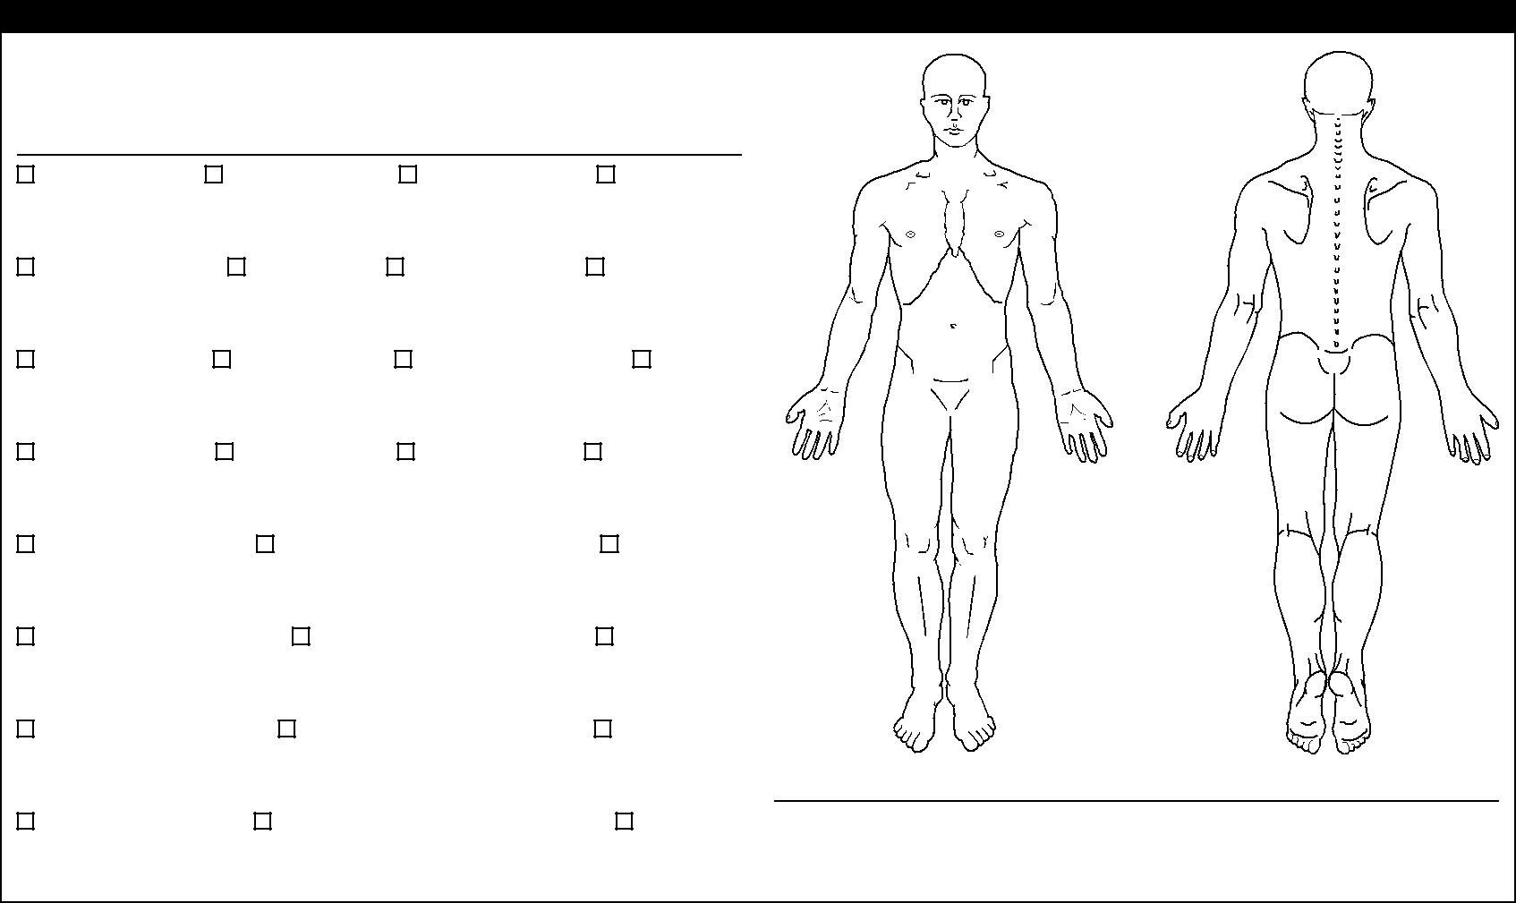
Use the diagram and pain key to the right to indicate areas and type of pain. Use the chart below to indicate pain intensity and limitations.

Pain intensity levels

No Pain | Moderate pain | Severe pain | Terrible pain
Sleeping
No problem | Disturbed | Very disturbed | Cannot sleep
Work - Can do:
Usual work | 50% of work | 25% of work | No work
Frequency of pain
25% of time | 50% of time | 75% of time | 100% of time
Travel
No problem | Moderate pain on trips |  | Severe pain
Recreation - Can do:
All activities | Some activities |  | No activities
Walking
Can walk fine | Pain after 1/2 mile |  | Cannot walk
Sitting
No pain sitting | Some pain while sitting |  | Cannot sit

Pain Key

Ache | Numbness | Pins & Needles | Burning | Stabbing
^ ^ ^ ^ | = = = = | 0 0 0 0 | X X X X | / / / /

Web of Wellness

Health and wellness are a balance

Mental Health Physical Health
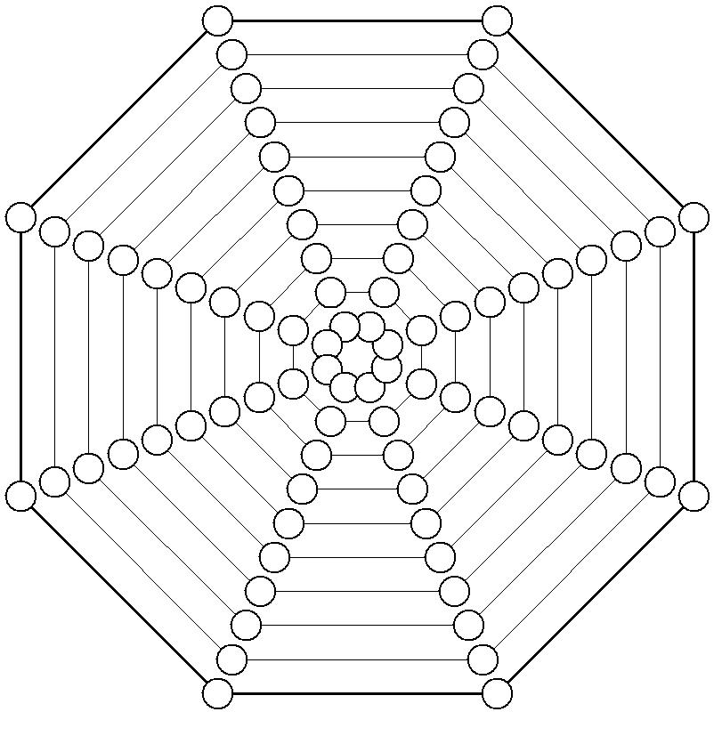

of many things. Many factors affect our lives in various ways. These factors weave a web of health and well-being.

Using the diagram to the right, choose your level of satisfaction in each of the areas. For example, if you are extremely satisfied with your career, shade in the “10” circle on the career health line.

1 = Extremely unsatisfied

5 = Neutral

10 = Extremely satisfied

Sexual Health

Career Health

10 | 9

10 | 9

8 | 7 | 6

8 | 7 | 6

10 | 10
9 | 9

8 | 8
7 | 7

6 | 6
5 | 5

 |  |  | 4 |  |  |  |  | 4
5 |  |  |  | 3 |  |  | 3 |  |  |  | 5 | 6
 | 4 |  |  | 2 |  | 2 |  |  |  | 4
 |  | 3 |  |  |  |  |  |  | 3
 |  |  | 2 |  |  | 1 |  | 2
 |  |  |  | 1
 |  | 3 | 2 | 1 | 1 |  |  | 2 | 3
 | 4 |  |  |  |  |  |  |  |  | 4
5 |  |  |  | 2 |  | 2 |  |  |  |  | 5
 |  |  |  |  |  |  |  |  |  |  |  | 6
 |  |  |  |  |  |  | 3
 |  |  |  | 3
 |  |  | 4 |  |  |  |  | 4

5 | 5
6 | 6

 | 8 | 9 | 10
7

7 | 8 | 9
 |  |  | 10

Financial Health

Spiritual Health

7 | 7
8 | 8

9 | 9
10 | 10
Social Health | Family Health

Commitment

On a scale from 1-10, how committed are you to correcting your problem(s)?

not committed 1 2 3 4 5 6 7 8 9 10 very committed

© 2014 Acupuncture Media Works • 1-866-696-7577 • www.acupuncturemediaworks.com

Acupuncture is an effective form of health care that has evolved into a complete and holistic medical system.

Acupuncturists and practitioners of Traditional Chinese Medicine (TCM) use this non-invasive healing modality to help millions of people get well and stay healthy.

When a patient seeks Acupuncture care and is accepted as a patient for such care, it is essential for both patient and Acupuncturist to be working toward the same objectives in order to prevent any confusion or disappointment.

The main objective of Acupuncture is to determine where there are imbalances in the body as they relate to TCM. When the flow of Qi (the vital energy that flows throughout the body) is disrupted, illness and disease may occur. An imbalance in any of the 14 main Meridian channels causes an alteration in the flow of Qi through the body. This can result in a lessening of the body’s innate ability to heal itself and express maximum health potential.

Once imbalances are detected, various treatment modalities may be employed to correct these imbalances. Any health condition(s) or disease(s) presented by the patient will be treated according to TCM only and treatment will relate only to the quantity, quality and balance of Qi.

The ONLY practice objective is to detect and correct imbalances within Meridian channels using Acupuncture and TCM techniques.

Patients will be advised if a non-Acupuncture related or otherwise unusual finding is encountered during the course of an Acupuncture examination. If advice, diagnosis or treatment of those findings is desired, patients will be referred to a qualified health care professional.

I, ______________________________, have read and fully understand the above statements.

All questions regarding the acupuncturist’s objectives pertaining to my care in this office have been answered to my complete satisfaction. I therefore accept Acupuncture care under these terms.

Signature _________________________________________ Date ____________

© 2014 Acupuncture Media Works • 1-866-696-7577 • www.acupuncturemediaworks.com

